Energy Metabolism = overall use of chemical energy; includes acquisition and production of usable energy (from catabolism of foodstuffs → ATP) and use of ATP
- It is usually assumed that production and use are in balance because ATP is not stored within the body to any great extent
- Example: skeletal muscle ATP = 5 mmoles/L intracellular fluid (this amount is capable of sustaining full contraction for only a few seconds)

Metabolic Rate = amount of energy used per time
- Aerobic = oxidative metabolism of foodstuffs → ATP (e.g., 38 ATP/glucose)
- Anaerobic = ATP production without oxidative metabolism (glycolysis [glucose → lactate] is most common mechanism) → glycolysis yield is 2 ATP/glucose, so less efficient but much faster.

Basal Metabolic Rate (or Standard or Resting MR) = minimum metabolic rate required for maintenance. Measured in postabsorptive state on resting animal during resting phase of the daily cycle at specified temperature (temps. where no energy spent on thermoregulation for endotherms). Also, animal is not growing or reproductively active for true BMR.

MEASUREMENT OF METABOLIC RATE

- DIRECT
- Calorimetry = measures total heat production of an organism (HP = heat of combustion of substrates – heat of combustion of excreted materials)
- HP is directly related to the amount of substrate metabolized
- Measured by placing an animal inside a calorimeter. Accurate measurement and calculation of HP is complex and difficult. Confounding factors include heating of ingested food, heating of inspired air, vaporization of water to humidify air, external work done by animal.

- INDIRECT
- Laboratory
- Oxygen Consumption – because oxygen is required for aerobic metabolism, the amount of oxygen that an animal consumes can be considered a measure of their energy metabolism
- This works because the amount of heat produced for a given quantity of oxygen consumed is nearly constant, regardless of the substrate being oxidized.
- (SEE P. 140, Willmer et al.)
- Example: Carbohydrates yield 20.9 kJ/L O₂ and proteins yield 18.6 kJ/L O₂ (fats in between). These differ by only 10%, and in most cases a combination of fuels is being utilized, so the error is less than this maximum value. So 20 kJ/L O₂ is usually used to covert oxygen consumption to heat production.
- Oxygen consumption is the most common method for measurement of metabolic rate and the two terms are often used interchangeably.
- Oxygen consumption, however, is an effective measure of aerobic metabolism only. This is sufficient in most cases (outside of strenuous exercise or hypoxic conditions) because the anaerobic contribution to energy provision is very small.

- Carbon Dioxide Production = carbon dioxide is produced as a by-product of aerobic metabolism, so CO₂ production can also be used as a measure of aerobic metabolic rate. However, it is not as accurate as oxygen consumption, because HP/CO₂ can vary up to 34% with the substrate being oxidized. (Fat = 6.7 kcal/L CO₂ and Carbo = 5.0 kcal/L CO₂).
- Also, there is a large pool of readily mobilized carbon dioxide in the body, mainly as HCO₃⁻ in the blood, which interferes with measurement of CO₂ production).

Respiratory Quotient (RQ) = CO₂ produced/O₂ consumed
- Utility of RQ is that it provides some idea of what substrates are being metabolized (SEE ENERGY SUBSTRATES TABLE, p. 140 in Willmer et al.)

- Field
- Doubly labeled Water (D₂O¹⁸) → D = H² (deuterium)
- Method:
- Inject
- Equilibrate (approx. 1 hour)
- Sample [initial]
- Release
- Recapture (within 1-2 days)
- Sample [final]
- Theory:
- D₂O¹⁸ equilibrates with water in the rest of the body; gives H₂O¹⁸, D₂O (HH²O), and CO₂¹⁸
- Deuterium lost only through water loss
- O¹⁸ lost both through water and CO₂¹⁸
- Difference between isotope turnover rates ([initial] – [final]) allows estimate of CO₂ production and estimates of MR (assume RQ = 0.85, so 24J/ml CO₂ → HP)
- FMR estimates vary depending on ambient humidity, activity of the animal, and a number of other factors, so measurement of MR by doubly labeled water is not very precise (and remember that CO₂ production wasn’t that great of a measure of MR anyway), but it gives a ballpark (± 10%) estimate of FMR
- FMR in animals is generally is about 2-4X BMR

- Heart Rate Monitoring
- Method:
- Attach or implant transmitter that measures heart rate of animal
- Release animal into wild
- Detect transmitter signal remotely OR recapture animal to remove data logger
- MR vs. heart rate must be calibrated beforehand (best done for each individual)
- Heart rate sometimes varies with type of activity
- If calibrated appropriately, gives good measure of MR (and works over short time periods)

- Time-Activity Budgets
- Method:
- Measure MR (oxygen consumption) for different activities in the lab
- Measure time spent in these various activities in the field
- Add up the MR for times spent in different activities → FMR estimate
- Difficulties with this method arise in getting accurate MR estimates for the multitude of different activities and because environmental conditions usually vary from those in the lab.
- But, again, this method provides ballpark estimates of FMR with careful observation. Usually in fairly close agreement with doubly labeled water estimates.

RESTING METABOLISM

Effectors of RMR include: age, sex, circadian phase, season, digestive state, phylogeny, body size, temperature (ectotherms), and habitats and habits (life history).

- Circadian Phase = RMR higher during active phase than during resting phase of daily cycle for endotherms (about 20% difference for small animals).
- Digestive State = energy is required to digest foodstuffs. This energy is called the Heat Increment of Feeding (HIF). HIF differs for different substrates:
- Carbohydrates = 6% (% of calories present in food needed to digest it)
- Fats = 13%
- Protein = 30%
- RMR higher when digesting than when digestive tract is empty (up to 50% or more higher when digesting)

- Phylogeny
- BMR varies among different vertebrate classes (Endotherms average about 10X greater than similar-sized ectotherms)
- Variation may also exist, to a lesser extent, between taxonomic Orders and Families

- Habitats and Habits – BMR may vary with the living environment or with food habits.
- Examples: For birds – tropical species tend to have lower BMR than those from higher latitudes; For mammals: Carnivores tend to have higher BMR than frugivores and folivores

- Body Size – within various vertebrate groups, body size has a very marked effect on metabolism. This relationship also holds for invertebrates.
- Relationship between MR and size is an allometric function = the dependent variable changes proportionately with the independent variable (MR with size in this case)
- General Form of allometric equation: Y = aX^{b}; for MR and size: MR = a(mass)^{b}
- This equation yields an exponential relationship, log-log transformation gives a straight line with a slope b and an intercept a. Equation: log MR = log a + (b * log mass)
- Since pioneering work in the 1950s the slope of this line (b) has been considered to be approximately 0.75 for most animals on an interspecific basis (may vary substantially from this value on an intraspecific basis)
- Newer analyses for birds and mammals (groups with the most MR measurements) using new statistical approaches and carefully standardizing MR measurements suggest that slopes for the BMR vs. mass relationship are closer to 0.67 than to 0.75
- MR does not vary as rapidly as mass (not 1:1)
- Mass-specific slope (MR/g) = -0.25 or -0.33 (inverse of total MR slope)
- This means that small animals have a relatively greater metabolic requirement than large animals and need more food to support a given amount of tissue
- (SEE HANDOUTS FOR MR vs. MASS RELATIONSHIPS)
- Why is this slope 0.75 or 0.67?
- Slope = 1 if MR directly proportional to body size
- Surface Area increase with Mass^{0.67}, so if MR directly proportional to surface area would see MR = Mass^{0.67}. Because diffusion and heat exchange occur across surfaces, it might be expected that metabolic rates would scale with surface area. Recent results for birds and mammals suggest this might be the case.
- However, the slope of 0.75 is still pervasive among different groups of organisms. One suggestion for the slope of 0.75 is that it represents a compromise between size and surface area.
- Another suggestion is the Fractal Model for Metabolic Scaling, which suggests that the 0.75 slope is the result of geometric branching patterns of respiratory and circulatory systems responsible for delivering oxygen and nutrients to tissues. According to this model, the fractal branching pattern of these tubes impacts how resources are taken up, transported and transformed within the body. The model is mathematically complicated, but predicts a slope of 0.75. Not generally accepted at present.
- Intercept on the log-log plot gives the metabolic rate of a 1 g animal (since log 1 = 0). This tells us something of the relative metabolic intensities between groups (endotherms higher than ectotherms, birds highest of all vertebrates)
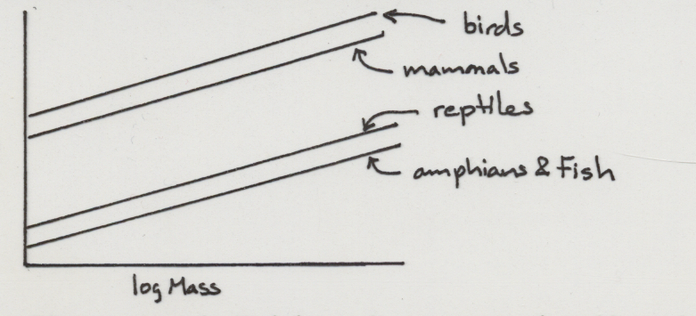

log MR

- Bottom Line = energetically it is much more expensive to be endothermic; it is also more energetically expensive to be small.

ACTIVITY METABOLISM

- Increased activity results in increased aerobic metabolism up to a maximal MR that can be supported aerobically (aerobic capacity)
- Activity may still increase beyond this level, but it must be supported by anaerobic metabolism → consequences later
- Fry (1947) – capacity for oxygen consumption during activity in trout. The situation is similar in other vertebrates.

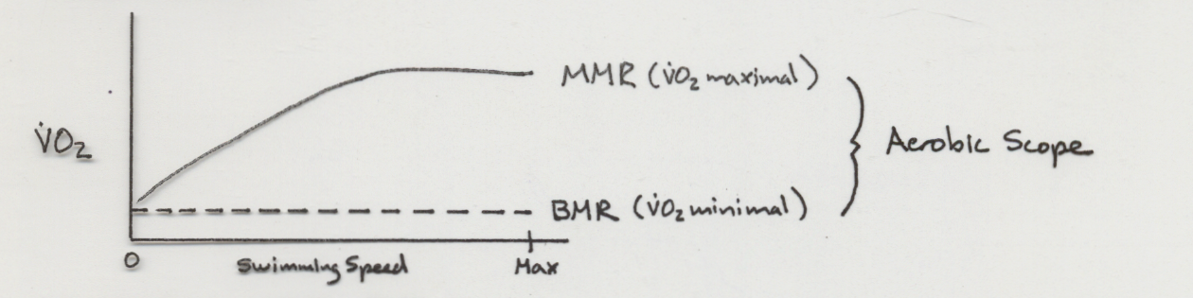

- Aerobic Scope = MMR – BMR
- Factorial Scope = MMR/BMR; generally for vertebrates factorial scopes are about 10 (range: 5-36), some invertebrates much higher
- Aerobic scope generally higher for active animals than for sluggish animals
- Aerobic MMR about an order of magnitude higher for endotherms than for ectotherms of similar size
- Temperature affects capacity for activity in ectotherms. Optimal performance usually occurs at temperatures characteristic of where the organism lives.
- (SEE HANDOUTS AND TEXT TABLES ON AEROBIC SCOPE)

MEASUREMENT OF MAXIMAL OXYGEN CONSUMPTION (MMR)

- Exercise – treadmills, wind tunnels (flying), swimming
- Cold Exposure – decrease temperature until animal becomes hypothermic (measures oxygen consumption associated with thermogenesis). Only works for endotherms.
- Exercise generally shows greater MMR than cold exposure
- Birds: exercise = 8-14 X BMR, up to 25 X; cold = 4-7 X BMR, up to 9 X
- Dog: exercise = 13 X BMR; cold = 8 X BMR
- Indicates full aerobic potential of the muscles is not available for HP in the cold. Why Not?
- Muscle mass recruited is less
- Q₁₀ effects
- Limitations to blood flow by continuous shivering in the muscles

Anaerobic Scope = maximal rate of lactate formation by glycolysis during activity minus resting lactate production
- Measure as whole-body lactate, can then convert lactate produced into quantities of ATP generated
- Anaerobic glycolysis produces ATP much faster than aerobic pathways and can therefore support more intense activity than can aerobic metabolism. However, it is much less efficient than aerobic metabolism (energy yield per substrate is low) and can’t be sustained for long periods (lactate builds up and is deleterious to muscle function, as well as having negative impacts on enzyme function and hemoglobin loading of oxygen)
- Anaerobic activity results in Oxygen Debt (consists of two components)
- Lactacid = reconversion of lactate to glucose and glycogen
- Alactacid = restoration of ATP and phosphocreatine stores
- Alactacid component restored quickly, repayment of lactacid component takes much longer and varies widely among taxa (e.g., diving mammals = minutes, fish and reptiles = several hrs)
- Why lactate as an end product instead of pyruvate, since lactate is much more deleterious?
- Has to do with balancing oxidation/reduction reactions: NAD⁺/NADH ratio must be precisely regulated because it is a metabolic modifier and because NAD⁺ must be regenerated for use in glycolysis
- Pyruvate → Lactate is catalyzed by Pyruvate Dehydrogenase (which also converts NADH → NAD⁺). The reverse reaction NAD⁺ → NADH occurs at an earlier stage in glycolysis by the enzyme Glyceraldehyde-phosphate Dehydrogenase.

COMPARATIVE ASPECTS
- There is not much difference in maximum anaerobic capacities between vertebrate groups (ectotherms generally slightly greater than endotherms, but of the same order of magnitude)
- The anaerobic contribution to ATP production makes up a much greater percentage of total ATP production during maximal activity in ectotherms.
- The total capacity for burst activity is apparently similar for vertebrates of similar size
(SEE HANDOUT ON AEROBIC/ANAEROBIC ATP PRODUCTION)

WHY ENDOTHERMY? (Show Larson Cartoon)

Advantages Disadvantages
1. Constant T_{b} 1. High energetic cost
2. Increased sustained activity 2. Decreased energy available for growth and reproduction
3. Resistance to freezing 3. Increased predation risk association with increased foraging requirements
4. New niches available

- When did endothermy evolve?
- likely near the origin of mammals and birds in the Mesozoic
- Mesozoic was the most thermally equable period in the earth’s history

- Why did endothermy evolve?

- Thermoregulatory Model = contends that endothermy evolved to maintain constant high T_{b}.
- Because of the warm climates, however, maintaining a high constant T_{b} was not that much of a problem during the Mesozoic.
- Difficult to envision much of an advantage to intermediate stages according to this model. An elevation of 3-5X reptilian MR is necessary to gain any thermoregulatory benefit.

- Aerobic Capacity Model = contends that endothermy evolved as a by-product of selection for increased sustained activity
- Intermediate steps are advantageous in that even small increments of MR help to increase sustained activity
- Evolutionary Scenario:
- cellular changes (increasing numbers of mitochondria) led to increased aerobic capacity and increased sustained activity, RMR increases as a by-product
- high numbers of mitochondria in cells require enhancement of oxygen uptake and transport system
- eventually this reached a level of metabolic HP (at rest) sufficient for endothermy
- Problem: RMR largely a function of central tissues (brain, heart, liver, gut), whereas aerobic capacity is largely a function of skeletal muscles. The connection between the two is not obvious

